Date and time of observation: Date____/___/____ Time

Breathing Changes | Voice or Vision Changes | Swallowing Changes | Behavioral Changes | OTHER
 Difficulty Breathing   Hyperventilation   Unable to breathe  Other: |  Raspy voice   Hoarse voice   Coughing   Unable to speak   vision changes |  Trouble swallowing   Painful to swallow   Pain to throat   Nausea /Vomiting   Drooling |  Agitation   Amnesia   PTSD   Hallucinations   Combativeness |  Dizzy or faint   Loss of consciousness   Headaches   Urination   Defecation   Hearing changes

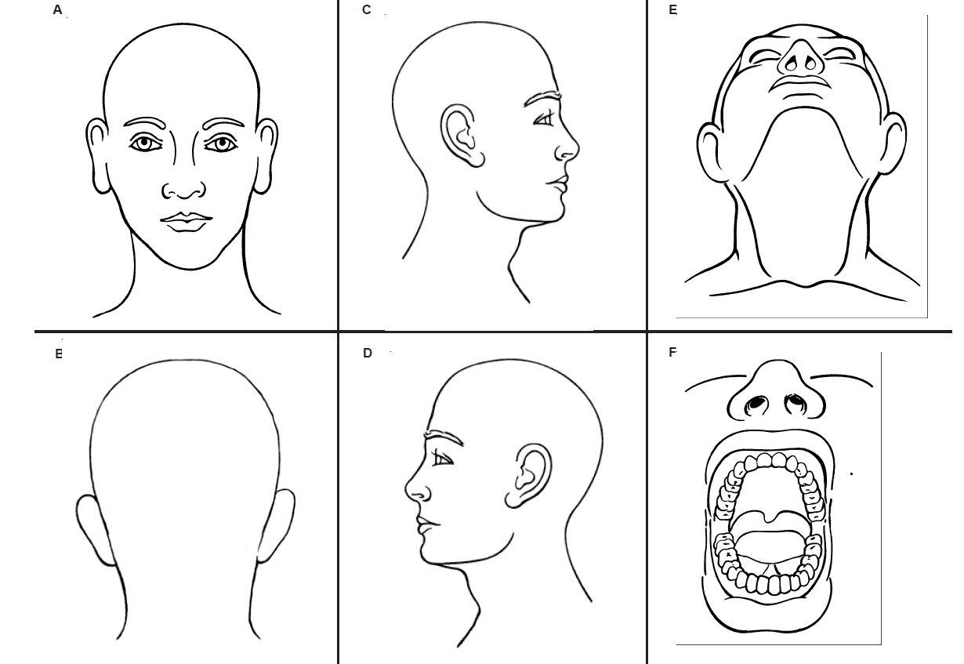
Use diagrams to mark visible injuries

Face | Eyes & Eyelids | Nose | Ear | Mouth
 Red or flushed   Pinpoint red spots (petechiae)   Scratch marks |  Petechiae to R and/or L eyeball (circle one)   Petechiae to R and/or L eyelid (circle one)   Bloody red eyeball(s) |  Bloody nose   Broken nose (ancillary finding)   Petechiae |  Petechiae (external and/or ear canal)   Bleeding from ear canal |  Bruising   Swollen tongue   Swollen lips   Cuts/abrasions (ancillary finding)
Under Chin | Chest | Shoulders | Neck | Head
Redness   Scratch marks   Bruise(s)   Abrasions |  Redness   Scratch marks   Bruise(s)   Abrasions |  Redness   Scratch marks   Bruise(s)   Abrasions |  Redness   Scratch marks   Fingernail marks   Bruise(s)   Swelling   Ligature mark |  Petechiae   Hair pulled   Bump   Skull fracture   Concussion (diagnosed medical)

Method and/or Manner:

How was the victim strangled?
 One Hand (R or L)  Two hands  Forearm (R or L)  Knee/Foot
 Ligature (Describe):__________________________________________________________
 How long? ______ seconds ________ minutes or can’t remember?
Document any jewelry suspect had on (rings bracelet):_________________________________

- From 1 to 10, how hard was the suspect’s grip? (Low): 1, 2, 3, 4, 5, 6, 7, 8, 9, 10 (high)
- Continuous pressure? Increased pressure?
- From 1 to 10, how painful was it? (Low): 1, 2, 3, 4, 5, 6, 7, 8, 9, 10 (high)

 Multiple attempts: ________________  Multiple methods: ____________________

Is the suspect RIGHT or LEFT handed? (Circle one)

Clothing Collected: | YES |  | NO
Evidence Collected: | YES |  | NO
Were they simultaneously smothered while being choked? Nose or mouth covered? Shaken? Straddled? Restrained? | YES |  | NO
Head pounded against wall, floor or ground? (possible concussion) | YES |  | NO
Any visual changes now (describe)? | YES |  | NO
Any hearing changes now (describe)? | YES |  | NO
Any breathing changes now (describe)? | YES |  | NO
Any changes in consciousness now (describe)? | YES |  | NO
Victim Interview:

When you were being choked what did you think was going to happen?

What are you able to remember about why they stopped choking you?

Is there anyone who might have been in a position to have heard or seen what was happening? (names contact #s)

What was their demeanor before they started to choke you? Did they say anything to you?

Can you describe the expression on their face while choking you?

What could you see, hear, smell, feel, taste, what caused pain, or pressure?

Have there been any other domestic violence incident with them? Yes No
Details:

Have they choked / strangled you in the past? Yes No
Details:

Described any injuries sustained by victim:

Describe area the strangulation occurred:

Evidence of urination, defecation. Loose hair clumps. Missing earrings/jewelry, defects in wall, or ligatures:

